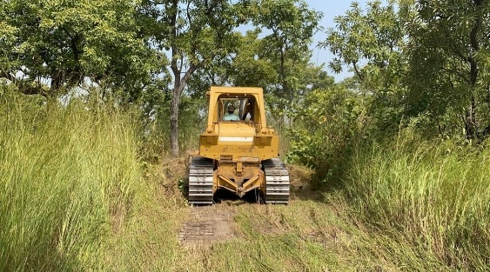

Hello brothers and sisters and Heartdwellers family.

This is just a quick video update on the Phase 1 Building of the City of God Community. Thank you so much for all who have donated and for those who have supported with your prayers and words of encouragement. Each one is greatly appreciated.

Just to give you an update so far we have raised £1,218 of the $19,300 we need, which is a wonderful blessing! In total we have now $2,300 and we are just shy of $1,500 to finish the surveying of the land. We have had some changes with Sister Ruth coming to Ghana, some good changes, and felt led by the Lord to wait until we get the land surveyed and began clearing before we bring any more souls here to help since we haven’t started building yet.

We get a large some of donation in the beginning of each month and initially we felt maybe it was time to focus our attention on putting the majority of the donations towards the building of the City of God because in that case, we can get things done within three months – but we discerned the Lord didn’t want it that way at all. He wanted us giving out money to the 20 people and organizations we support each month, and anyone else who was in need. Which leaves us scraping by again every month, after our donations go out.

I often remember a scene in Mother Teresa’s movie where donations came and she had a box of receipts that had certain needs and organizations written on it. She really wanted to began building the City of Peace, but after allocating all the donations to the needs in the box she had nothing left again to begin this project the Lord told her to build. The sisters and Her father were getting weary about

this, and she looked at them and shrugged saying: well, I guess Jesus is not in a hurry.

I chuckle when I think of that, as I scratch my head sometimes wondering: Lord, are we doing the right thing by giving out everything first? Because I know the City of God community *is* Your will, we just need provision. And I remember the scene and think: Lord, I know You told me to do this, but You don’t seem in a hurry, so maybe I shouldn’t be (laughs)

Either way family, we are hoping to have some part of the first phase started at least before the end of the year, God willing. I have been in Ghana for almost a year now and I realize I wanted to start building the community but the Lord wanted to build my foundation in this marriage so we would be solid, steadfast and united in His will. And we *are* on the road to that in the most beautiful way. Thank you for your prayers. As Father Derrick has been led by the Lord to start farming, in order to be equipped to farm on the City of God land.

We have been gifted quite a few acres of land that’s already cleared and ready to go, from a friend of his. Who will allow us to farm on the land then use the harvest we yield to help pay for the City of God community land clearing. However, even that cost money to get some machines and seedlings etc, which we do not have right now.

So family, continue to think of us, pray for us and donate whatever amount you can. It will be greatly appreciated to help with the From Jesus with Love outreach every week and also to help jump start the farming and surveying of the land. The next time we go to the farm land will have some pictures and videos for you guys.

God bless you family, until the next message